
INDIVIDUAL ASSIGNMENT
TECHNOLOGY PARK MALAYSIA
CT127-3-2-PFDA
PROGRAMMING FOR DATA ANALYSIS
UC2F2008CS(IS)
NAME: Choo Zhen Yang
TP NUMBER: TP051684
HAND OUT DATE: 22 SEPTEMBER 2020
HAND IN DATE: 23 NOVEMBER 2020
WEIGHTAGE: 50%
INSTRUCTIONS TO CANDIDATES:
1 Submit your assignment at the administrative counter.
2 Students are advised to underpin their answers with the use of references (cited using the Harvard Name System of Referencing).
3 Late submission will be awarded zero (0) unless Extenuating Circumstances (EC) are upheld.
4 Cases of plagiarism will be penalised.
5 The assignment should be bound in an appropriate style (comb bound or stapled).
6 Where the assignment should be submitted in both hardcopy and softcopy, the softcopy of the written assignment and source code (where appropriate) should be on a CD in an envelope / CD cover and attached to the hardcopy.
7 You must obtain 50% overall to pass this module.

Contents
Introduction 3
Main Content 4
Analysis 1: Mean Temperature of Each Month 4
Analysis 2: Mean Precipitation of Each Month 6
Analysis 3: Minimum Temperature of Each Month 8
Analysis 4: Minimum Visibility of Each Month 10
Analysis 5: Frequency of Minimum Visibility<201m Each Month 12
Analysis 6: Mean Wind Direction Of Each Day 14
Analysis 7: Frequency of Wind Speed > 34 mph on each Month 16
Analysis 8: Humidity of Origin 18
Analysis 9: Frequency of Precipitation != 0 20
Analysis 10: Frequency of Wind Gust != 0 22
Analysis 11: Relationship between Difference in Temperature and Dewpoint with Humidity 24
Analysis 12: Maximum Wind Gust of Each Month 26
Analysis 13: Relationship between Wind Speed and Wind Gust 28
Analysis 14: Frequency of Frost Occur Each Month 30
Analysis 15: Mean Humidity of Each Month 32
Analysis 16: Max Temperature of Each Month 34
Extra Feature 1 36
Extra Feature 2 37
Conclusion 38
References 39

Introduction
This report focuses on the data analysis implementation on hourly weather data. The data contains 17412 rows and 15 columns in total in which the column are origin, year, month, day, hour, temp, dewp, humid, wind_dir, wind_speed, wind_gust, precip, pressure, visib and time_hour. The data is related to the hourly meteorological data for LaGuardia Airport (LGA) and John F.Kennedy International Airport (JFK). The data is pre-process by filtering the NULL column and converting the measuring unit of the data. This analysis is done by using data visualization, exploration, and manipulation techniques to come out with information that is useful for management teams. This report contains analysis and graph that can be helpful for both of the airport discussed. The analysis is display in a graph format to show the relationship and the pattern over the year. The report also contains code explanation on how to achieve the particular result.
There are a few assumption made when analyzing the data. The first is the assumption of seasons. I assume there is a total of 4 different seasons on across the year which are winer, spring, summer, autumn. I also assume that the pressure column that have a null value to be the average pressure. As it is impossible for pressure to be 0. The third assumption is the wind gust that contains null value to be 0 as when the wind gust can be 0 if there are no any wind changing. The fourth assumption is the wind speed that contains null value is set to 0. The last assumption is the wind direction is also set to 0 for the null value.

Main Content

Analysis 1: Mean Temperature of Each Month
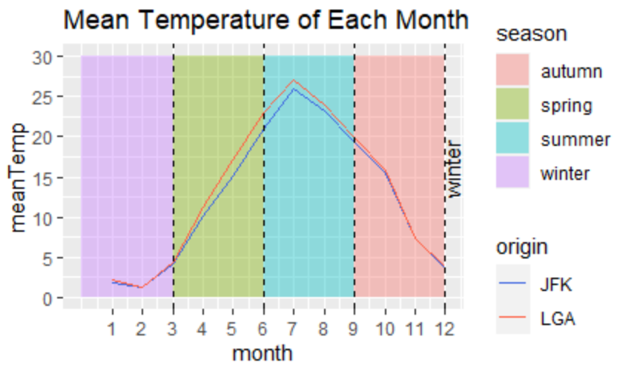
The graph above shows the mean temperature of each month according to different airport which are JFK and LGA. The season are categorized according to the background color of the graph. Purple indicates winter, green indicates spring, blue indicates summer and red indicates autumn. The winter words after December is also an indication of winter season. This graph helps the organization to differentiate the seasons on the particular year. By indicating seasons, organization can do preparation based on the seasons as the operation of aircraft is entirely different.
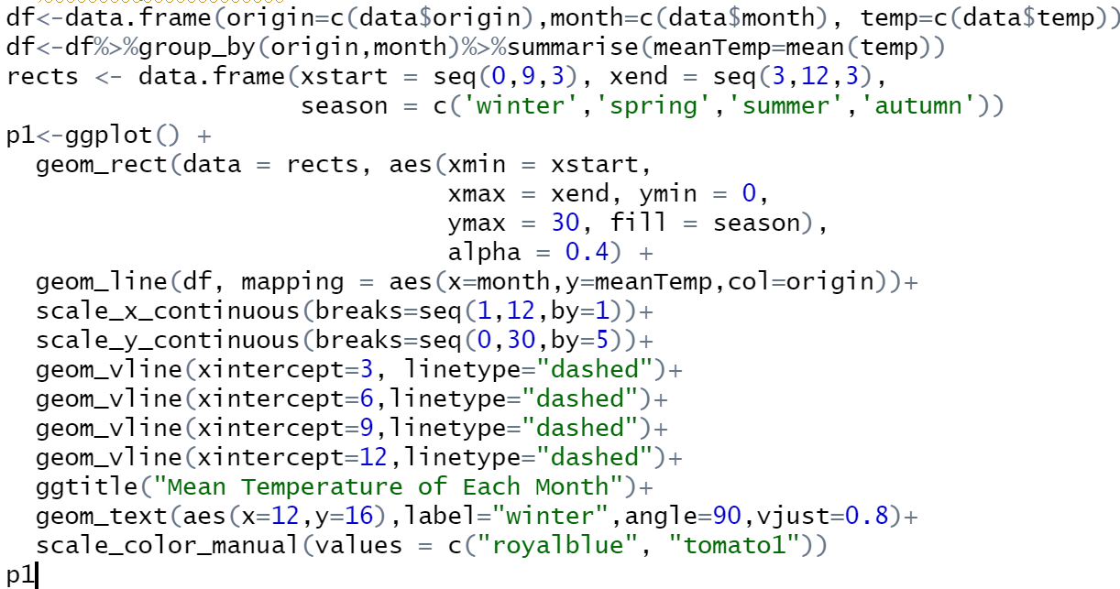
I started off by creating a data frame to store the data needed which are origin, month and temperature. Then, I group the data according to origin and month. Next, I summarized the data into a single row by taking the mean temperature for each month. I then created a data frame call rects which store the xstart, xend, and season column. I then start to plot the graph. I first use geom_rect to create rectangles. The xmin specifies where the rectangle start from the x-axis, xmax specifies where the rectangle ends at the x-axis. They ymin specifies the start point of the rectangle from the y-axis, and the yend specifies the end point of the rectangle from y-axis. The fill specifies the rectangle based on the season using different color of background. Alpha represent the opacity of the plot. I created the a line on the graph using geom_line which takes data from data frame “df”. I set the month to the x-axis, meanTemp to y-axis, and origin to col which draw 2 different color of lines represent 2 different origin. Then, I set the label value along the x and y axis which x axis start from 1 to 12 which the value increment by 1, I did the same to the label of y-axis. I plotted a vertical line on the x-intercept of 3, 6, 9, and 12 with the dashed line. I set the title using ggtitle and I write a text on the graph where the position is on the value of 12 for x-axis and 16 for y-axis, the name of the label is set to “winter” the word is position on the angle of 90 degree. I change the color of the lines to royalblue and tomato1.

Analysis 2: Mean Precipitation of Each Month
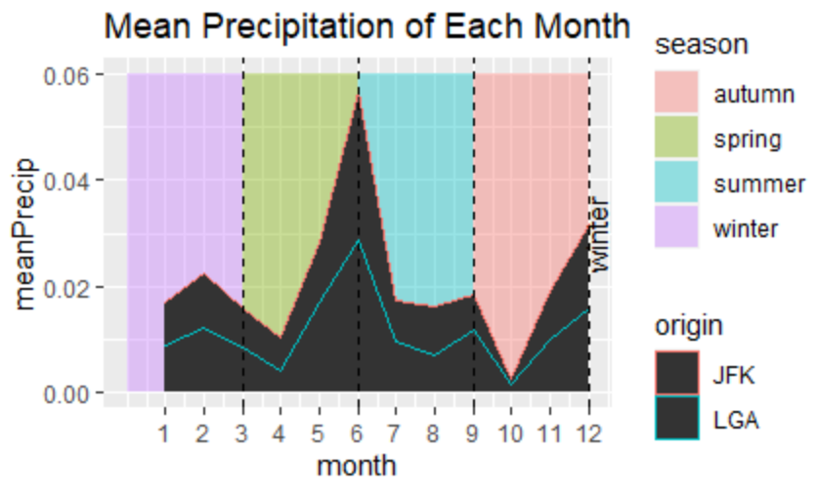
The graph above show the mean precipitation of each month based on the airport. The seasons is categorized based on the background color. The mean precipitation can remind organization to clean the runway on a daily routine especially in the spring season where it rains frequently as monsoon occur. Besides, on the winter season, they should also clean the runway frequently as the precipitation accumulation is quite a lot. By cleaning the runway, the air craft can avoid sliding over smooth and wet surface of runway with precipitation such as water and snow.
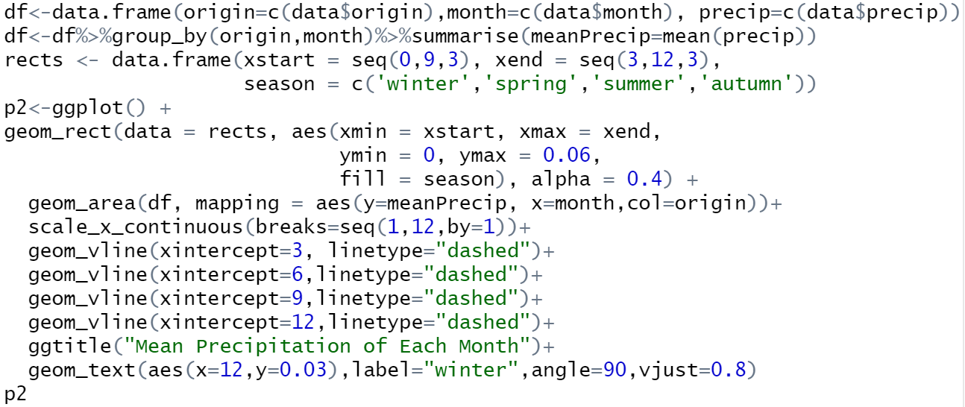
I started off by creating a data frame to store the data needed which are origin, month and precip. Then, I group the data according to origin and month. Next, I summarized the data into a single row by taking the mean precipitation for each month. I then created a data frame call rects which store the xstart, xend, and season column. I then start to plot the graph. I first use geom_rect to create rectangles. The xmin specifies where the rectangle start from the x-axis, xmax specifies where the rectangle ends at the x-axis. They ymin specifies the start point of the rectangle from the y-axis, and the yend specifies the end point of the rectangle from y-axis. The fill specifies the rectangle based on the season using different color of background. Alpha represent the opacity of the plot. I created an area graph on the graph using geom_area which takes data from data frame “df”. I set the month to the x-axis, meanPrecip to y-axis, and origin to col which draw 2 different areas represent 2 different origin. Then, I set the label value along the x and y axis which x axis start from 1 to 12 which the value increment by 1, I did the same to the label of y-axis which. I plotted a vertical line on the x-intercept of 3, 6, 9, and 12 with the dashed line. I set the title using ggtitle and I write a text on the graph where the position is on the value of 12 for x-axis and 0.03 for y-axis.

Analysis 3: Minimum Temperature of Each Month
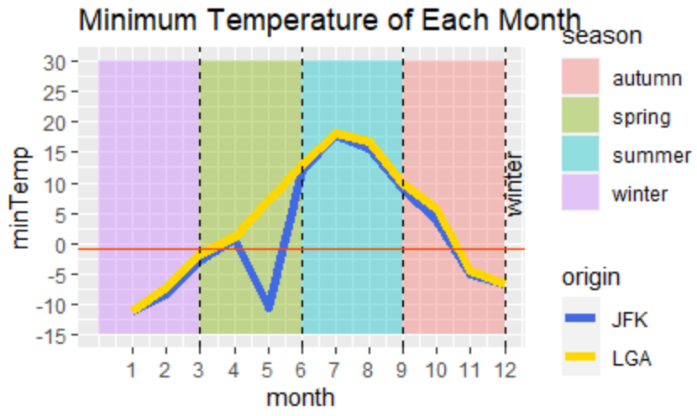
The graph above display the minimum temperature of each month. Like the previous graph, this graph also categorized seasons based on the background temperature. The minimum temperature of each month is recorded to indicate whether there is a need of using deicing fluid to help in defrost the airplane. The red line indicates the frozen value of the airplane which is -1 Degree Celsius.
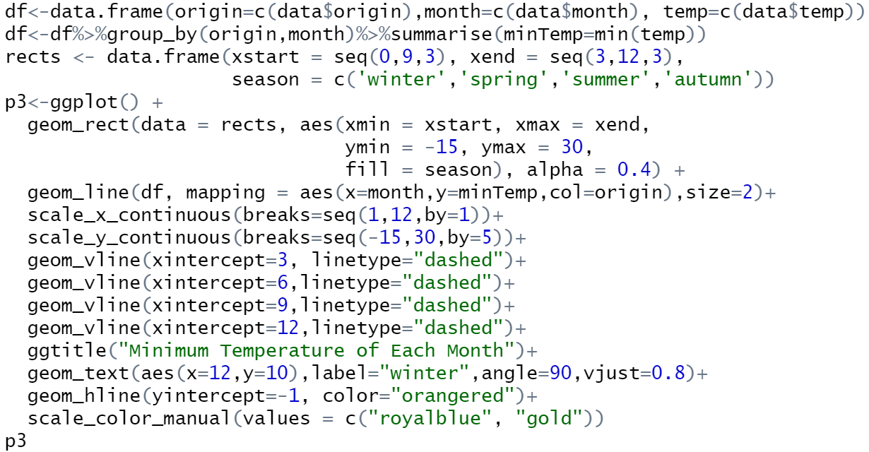
I started off by creating a data frame to store the data needed which are origin, month and temperature. Then, I group the data according to origin and month. Next, I summarized the data into a single row by taking the minimum temperature for each month. I then created a data frame call rects which store the xstart, xend, and season column. I then start to plot the graph. I first use geom_rect to create rectangles. The xmin specifies where the rectangle start from the x-axis, xmax specifies where the rectangle ends at the x-axis. They ymin specifies the start point of the rectangle from the y-axis, and the yend specifies the end point of the rectangle from y-axis. The fill specifies the rectangle based on the season using different color of background. Alpha represent the opacity of the plot. I created the a line on the graph using geom_line which takes data from data frame “df”. I set the month to the x-axis, meanTemp to y-axis, and origin to col which draw 2 different color of lines represent 2 different origin. Then, I set the label value along the x and y axis which x axis start from 1 to 12 which the value increment by 1, I did the same to the label of y-axis. I plotted a vertical line on the x-intercept of 3, 6, 9, and 12 with the dashed line. I set the title using ggtitle and I write a text on the graph where the position is on the value of 12 for x-axis and 16 for y-axis, the name of the label is set to “winter” the word is position on the angle of 90 degree. I change the color of the lines to royalblue and gold.

Analysis 4: Minimum Visibility of Each Month
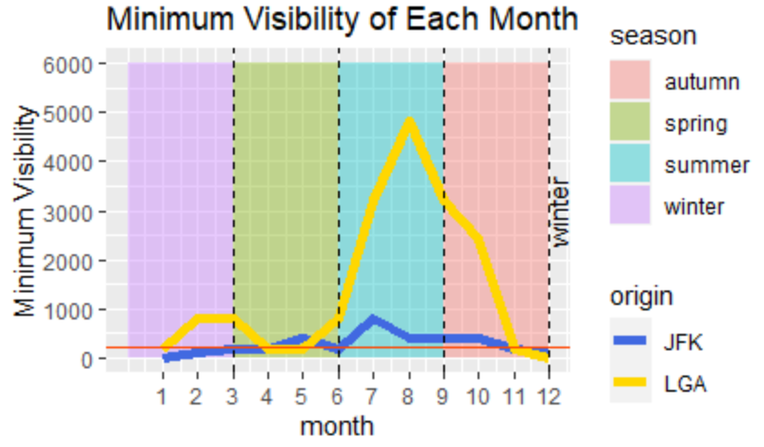
The graph above shows the minimum visibility of each month according to the airport. According to JFK, the minimum visibility to take off a flight is 1/8 of a mile. The red line on the graph indicates the minimum visibility for the takeoff. Organization can try to change the schedule of flight and schedules lesser flight on the particular month with visibility that prevent flight takeoff, or else the management group are required to delay the flight.
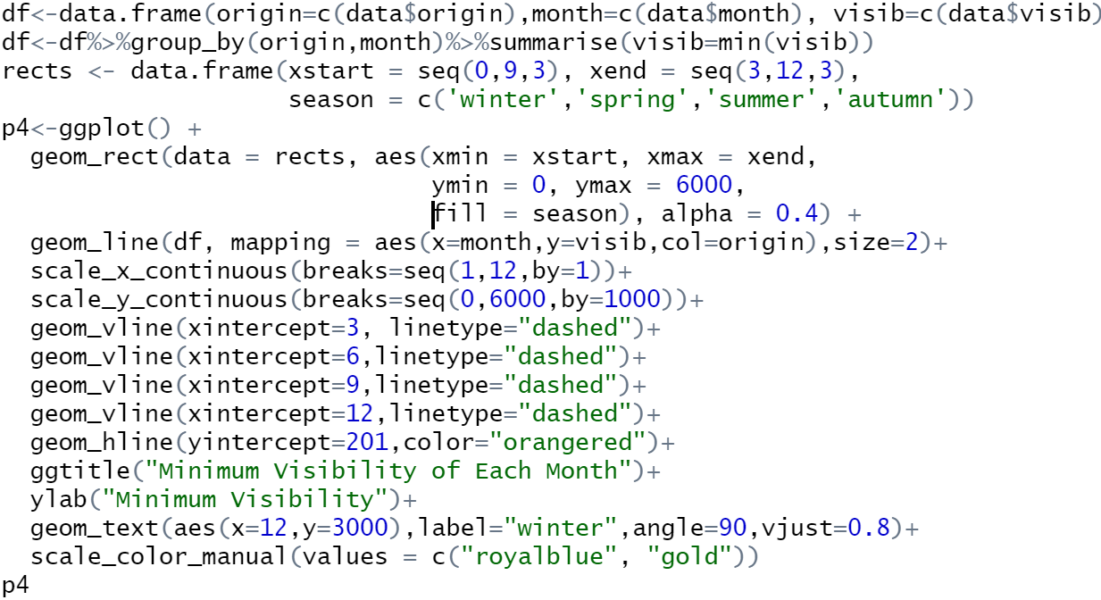
I started off by creating a data frame to store the data needed which are origin, month and visibility. Then, I group the data according to origin and month. Next, I summarized the data into a single row by taking the minimum visibility for each month. I then created a data frame call rects which store the xstart, xend, and season column. I then start to plot the graph. I first use geom_rect to create rectangles. The xmin specifies where the rectangle start from the x-axis, xmax specifies where the rectangle ends at the x-axis. They ymin specifies the start point of the rectangle from the y-axis, and the yend specifies the end point of the rectangle from y-axis. The fill specifies the rectangle based on the season using different color of background. Alpha represent the opacity of the plot. I created the a line on the graph using geom_line which takes data from data frame “df” and the size of line is set to 2. I set the month to the x-axis, meanPrecip to y-axis, and origin to col which draw 2 different color of lines represent 2 different origin. Then, I set the label value along the x and y axis which x axis start from 1 to 12 which the value increment by 1, I did the same to the label of y-axis. I plotted a vertical line on the x-intercept of 3, 6, 9, and 12 with the dashed line. Besides, I have also plotted a red horizontal line to indicate the value below it is not suitable for takeoff. I set the title using ggtitle and I write a text on the graph where the position is on the value of 12 for x-axis and 16 for y-axis, the name of the label is set to “winter” the word is position on the angle of 90 degree. I change the color of the lines to royalblue and gold.

Analysis 5: Frequency of Minimum Visibility<201m Each Month
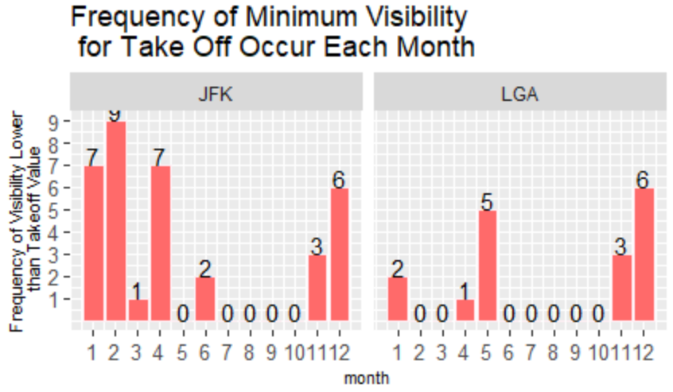
The graph above shows the frequency of minimum visibility(1/8mile) for takeoff occur each month. The graph is distributed based on the origin which on the left side is JFK and on the right side is LGA. On top of each bar there is a number that record the total frequency for each month. This can help management to figure out the number of the flight to delay based on how many times the frequency occur for each month as for a single occurrence, there will be more than 1 flight that is affected. For the month with 0 occurrence can proceed with the original schedule. For the month with high number of occurrences, management team can delay the flight.
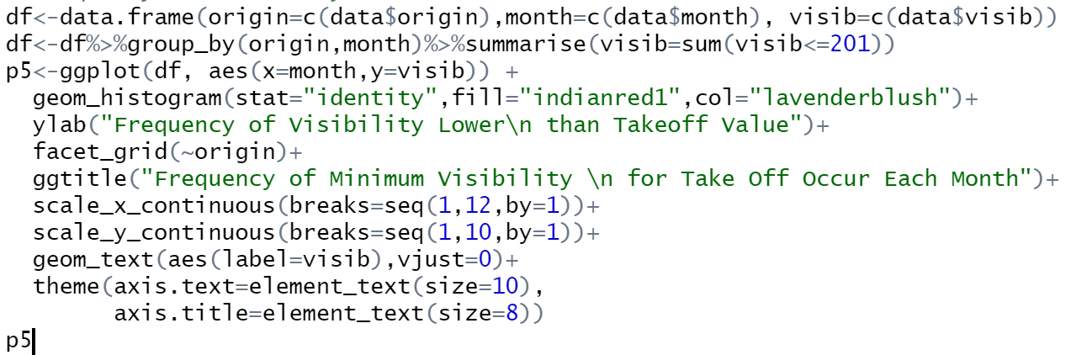
I started off by creating a data frame to store the data needed which are origin, month and visibility. Then, I group the data according to origin and month. Next, I summarized the data into a single row by taking the total row with visibility smaller or equal to 201m for each month. Next, I use the data from data frame “df”, the x-axis value is the month, and y value is visib. Next, I plot a histogram with the y-axis value to represent the value of my data unstead of frequency using stat=”identity”, and I change the color of bar. After that, the title of y-axis is changed using ylab. The label value of y and x-axis is also changed. The geom_text is used to display the value of each bar. Lastly, I changed the size of label of both axis and their title.

Analysis 6: Mean Wind Direction Of Each Day
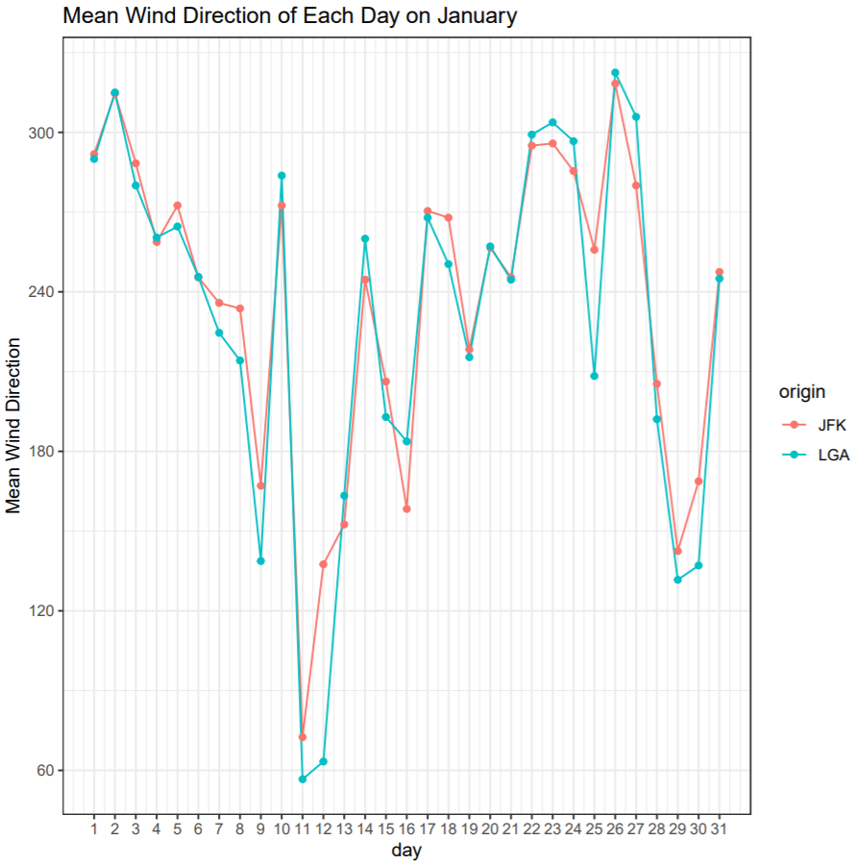
The graph above show the mean wind direction of each day based on that particular month. The blue line with dotted point represents LGA airport while the red line represents JFK airport. The mean wind direction can help the management team to decide which runway to use when takeoff and landings are performed. The wind direction can help to determine whether on that particular runway of airport is facing head wind or tail wind. For example, when the wind direction is 211 degree, the Runway 04/L is not suitable for takeoff as the runway is facing 31 degree (Jfkrotaryclub, 2017). This will produce a head wind that can highly affect the takeoff of airplane. The total number of graph in the pdf will be 12 as there is a graph for each month.
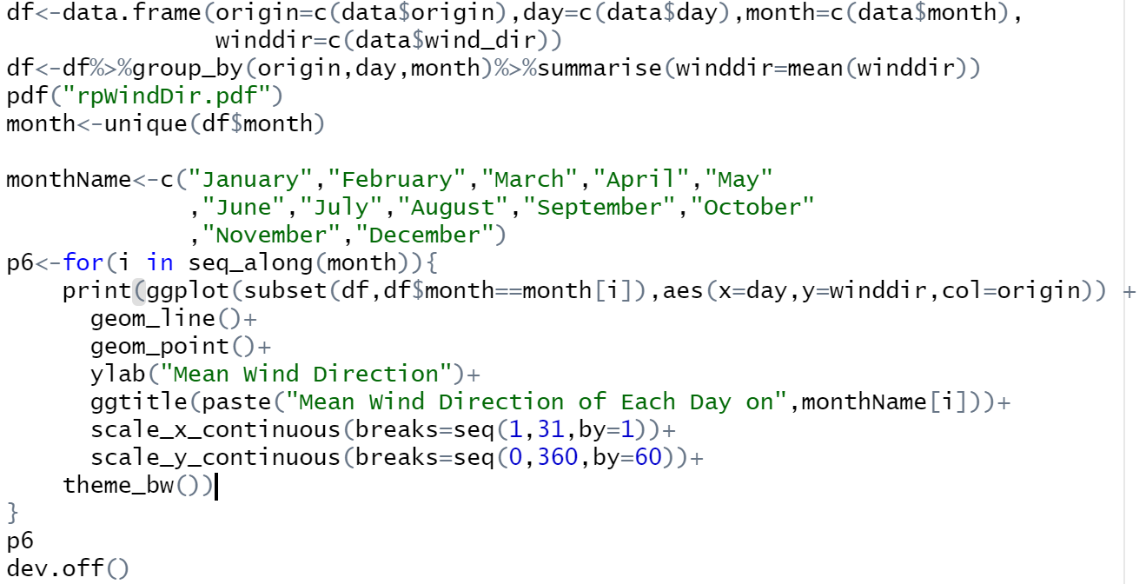
I started off by creating a data frame to store the data needed which are origin, day and month. Then, I group the data according to origin, day and month. Next, I summarized the data into a single row by taking the mean wind direction of each day of each month. Then, I declare a pdf file to store my graph. I then take all the unique value of the month without repetition of value. I created a data frame to store name of each month. I loop over the sequence of month using a for loop and I print the graph for each month. I take each data of each month from df as subset, and I use the value of day as x-axis for the graph, wind direction for y-axis of the graph, and the origin as separate lines. I use line and point in visualizing the data. The title of y-axis is changed. I use paste to concatenate the string “Mean Wind Direction of Each Day on” with each value in month name. The label value of x and y-axis is set. I then set the background theme of the graph.

Analysis 7: Frequency of Wind Speed > 34 mph on each Month
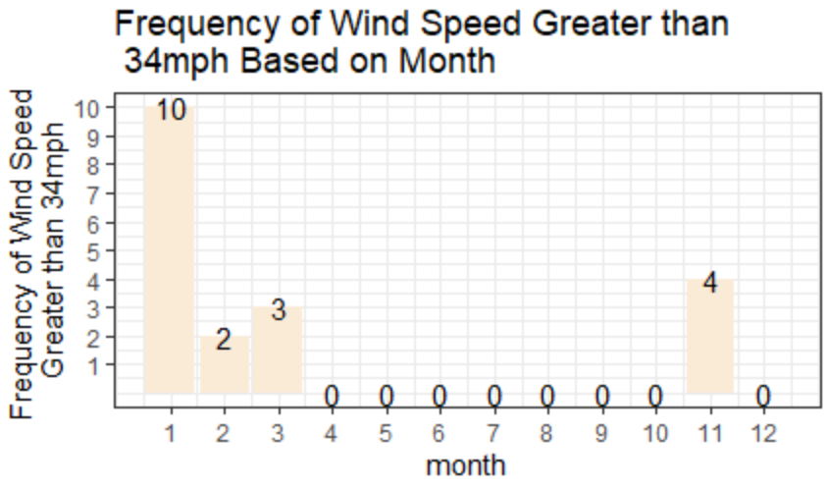
The graph above show the frequency of wind speed greater than 34 mph which is the maximum wind speed that is prohibitive for takeoff and landings (Schrader, 2019). This can help management team to decide in delaying the flight to takeoff to avoid any accident to happen. Besides, management team can also reduce the number of flights scheduled on that particular month.
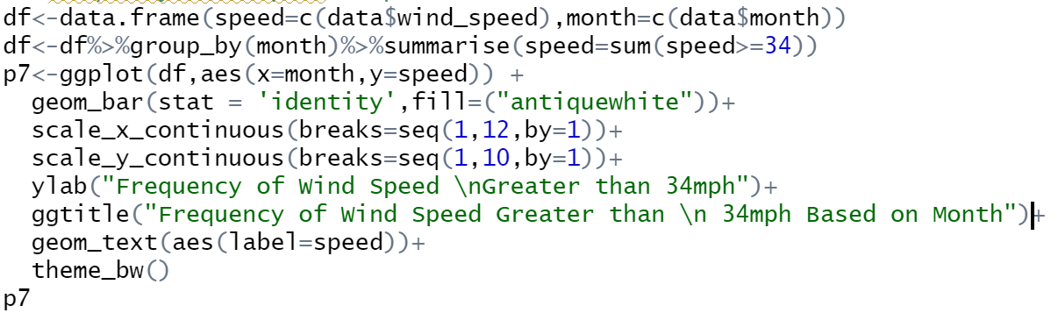
I started off by creating a data frame to store the data needed which are month and wind speed. Then, I group the data according to month. Next, I summarized the data into a single row by taking the total row with wind speed of more than 34 mph for each month. Next, I use the data from data frame “df”, the x-axis value is the month, and y value is speed. Next, I plot a bar chart with the y-axis value to represent the value of my data instead of frequency using stat=”identity”, and I change the color of bar. After that, the title of y-axis is changed using ylab. The geom_text is used to display the value of each bar. Lastly, I changed background theme of the graph.

Analysis 8: Humidity of Origin
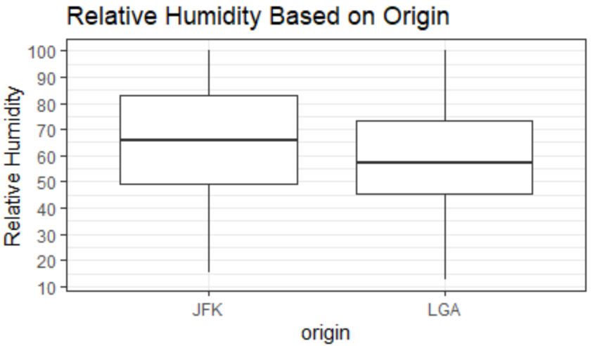
The graph above show a boxplot graph that compare the relative humidity between 2 origin which are JFK and LGA. According to (DiBonaventuro, 2017), air on the curved part of the wing will cause air to move by quicker, causing the bottom of the wing to have higher pressure which result in lift. If the air is humid, the airplane cannot produce the amount of lift it could compare to dry air. Thus, it requires a longer runway to gain speed before lifting. From the graph above, the airplane taking off from JFK is also requires to travel for a longer distance to create enough lift. When constructing the runway for JFK airport, the runway should be longer compared to LGA airport.
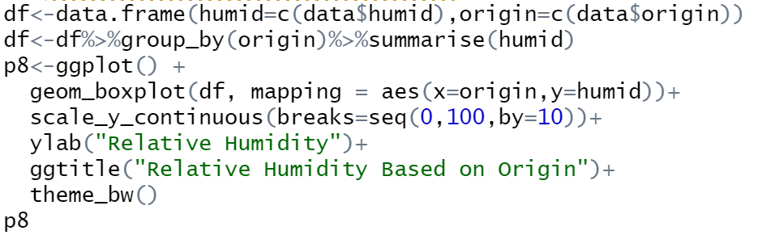
I started off by creating a data frame to store the data needed which are origin and wind speed. Then, I group the data according to origin. Next, I summarized the data into a single row by taking the humidity for each origin. Next, I use the data from data frame “df”, the x-axis value is the origin, and y value is humidity. Next, I plot a box plot graph using the data taken. I changed the label value of y-axis using scale_y_continuous. After that, the title of y-axis is changed using ylab. Lastly, I changed background theme of the graph.

Analysis 9: Frequency of Precipitation != 0
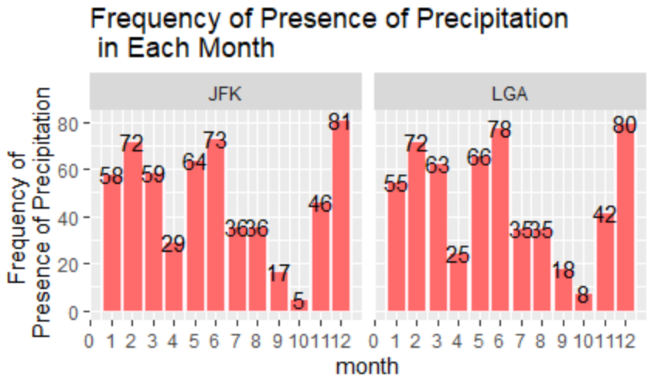
The graph above shows the frequency of presence of precipitation in each month. The precipitation includes snow and rain. These precipitations can actually block the vision of the pilot. Therefore, management team can appoint pilot with better experience in piloting so that the pilot can handle the situation better. Besides, on the month with more frequency of precipitation occur, management team can increase the frequency of cleaning the runway to avoid the sliding of airplane that can cause accident.
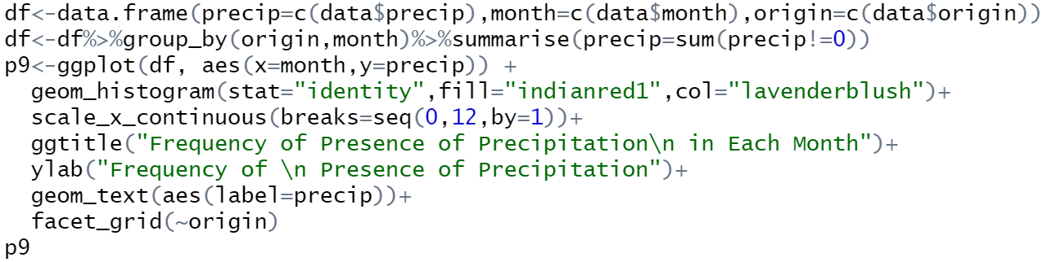
I started off by creating a data frame to store the data needed which are month, precipitation and origin. Then, I group the data according to month and origin. Next, I summarized the data into a single row by taking the total row with precipitation of not equals to 0 for each month. Next, I use the data from data frame “df”, the x-axis value is the month, and y is precip. Next, I plot a histogram chart with the y-axis value to represent the value of my data instead of frequency using stat=”identity”, and I change the color of bar. After that, the title of y-axis is changed using ylab and the title of the graph is changed using ggtitle. The geom_text is used to display the value of each bar. Lastly, I used facet_grid to split the graph into two using the origin data which has 2 values JFK and LGA.

Analysis 10: Frequency of Wind Gust != 0
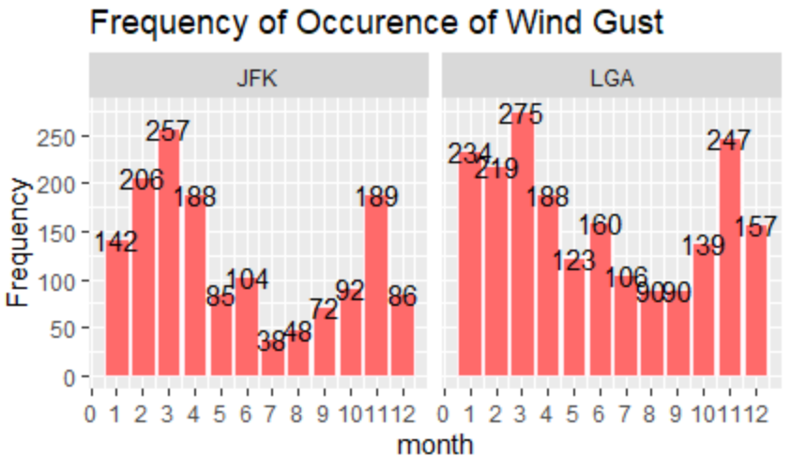
The graph above shows the frequency of occurrence of wind gust based on JFK and LGA airport. This can helps the analytics team to identify the wind change pattern based on different month. For example, in the month of March the occurrence of wind gust occurs the most. This indicates the instable of the wind which can cause accident to happen. Airport can give out warnings to the pilots to ensure that they are fully prepare if a sudden wind gust occur during a flight.
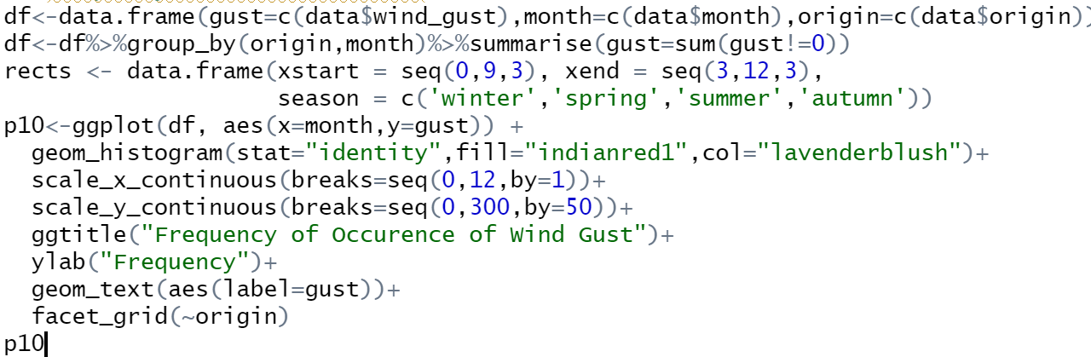
I started off by creating a data frame to store the data needed which are month, wind gust and origin. Then, I group the data according to month and origin. Next, I summarized the data into a single row by taking the total row with wind gust of not equals to 0 for each month. Next, I use the data from data frame “df”, the x-axis value is the month, and y is wind gust. Next, I plot a histogram chart with the y-axis value to represent the value of my data instead of frequency using stat=”identity”, and I change the color of bar. The label value of x and y-axis is set using scale_x_continuous and scale_y_continuous. After that, the title of y-axis is changed using ylab and the title of the graph is changed using ggtitle. The geom_text is used to display the value of each bar. Lastly, I used facet_grid to split the graph into two using the origin data which has 2 values JFK and LGA.

Analysis 11: Relationship between Difference in Temperature and Dewpoint with Humidity
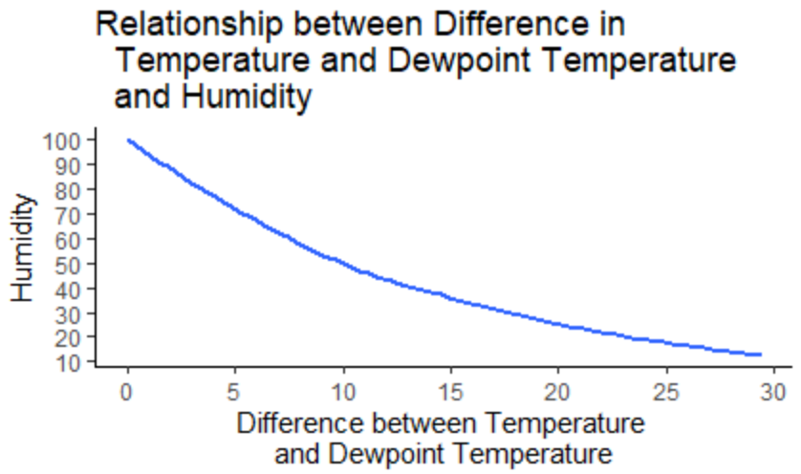
The graph above show the relationship between the difference of temperature and dewpoint temperature and humidity. The smaller the difference between temperature and dewpoint temperature, humidity will be higher. This can actually increase the number of clouds form in the sky which might decrease the visibility of the pilot. When there is a higher humidity, the chance of flying through turbulence might increase. Therefore, pilot should take other route to the destination.
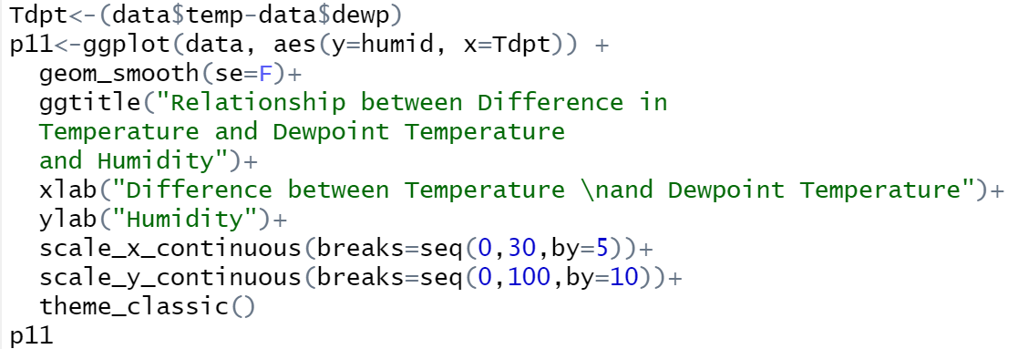
First, I assigned the value of temperature subtract dewpoint to a variable. Then, I assigned the require data which is humidity to y-axis and difference between temperature and dewpoint to x-axis. I created smooth graph with no confidence interval around the smooth graph. I then set the title for the graph, the title for x-axis and y-axis. I also set the label value of x-axis and y-axis to my desire value. Lastly, I set the background theme for the graph.

Analysis 12: Maximum Wind Gust of Each Month
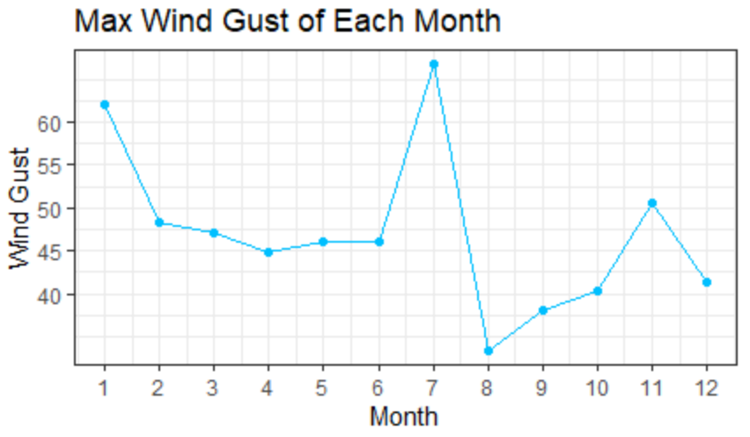
The graph above shows the max wind gust of each month. Wind gust occur only for approximately 20 seconds. This may not seem much as the duration of wind gust is so less that it seems to do nothing to a flight. However, what if the frequency of it happening is a lot in a short amount of time? This can actually render the takeoff of a flight for a short amount of time. If by any chances, the wind gust happens when the airplane is departing, this can actually affect the airplane. Therefore, airport can announce a delay between 15 to 30 minutes if the wind gust is strong enough to ensure the wind gust will not suddenly occur again.
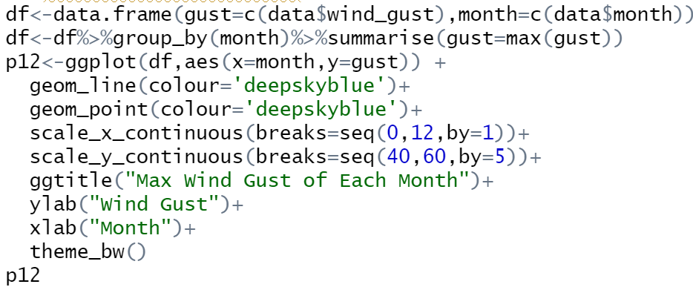
I started off by creating a data frame to store the data needed which are month and wind gust. Then, I group the data according to month. Next, I summarized the data into a single row by taking the max wind gust of each month. I use the value of month as x-axis for the graph, and wind gust for y-axis of the graph. I use line and point in visualizing the data. The label value of y and x-axis is changed. The title of y-axis and x-axis is changed. I then set the background theme of the graph.

Analysis 13: Relationship between Wind Speed and Wind Gust
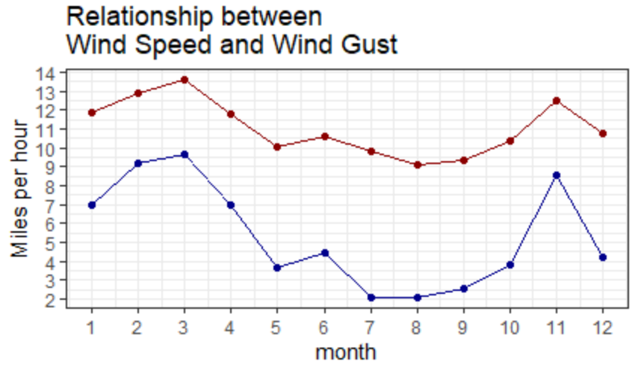
The graph above shows the relationship between wind speed and wind gust in which red line represents the wind speed and blue line represents the wind gust. As wind speed increase, the wind gust will increase.
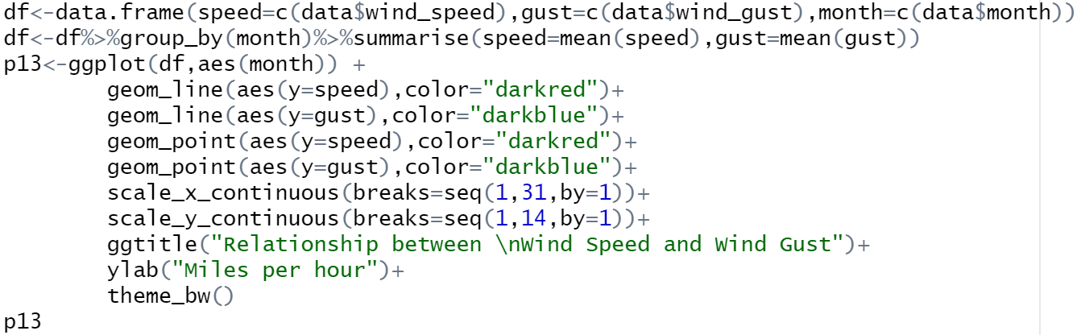 I started off by creating a data frame to store the data needed which are month, wind speed and wind gust. Then, I group the data according to month. Next, I summarized the data into a single row by taking the mean wind gust and wind speed of each month. I use the value of month as x-axis for the graph. I use line and point in visualizing the data. The first line and point take the value of wind speed and color of darkred. The second line takes the value of wind gust and color of darkblue. The label value of y and x-axis is changed. The title of y-axis title of graph is changed. I then set the background theme of the graph.

Analysis 14: Frequency of Frost Occur Each Month
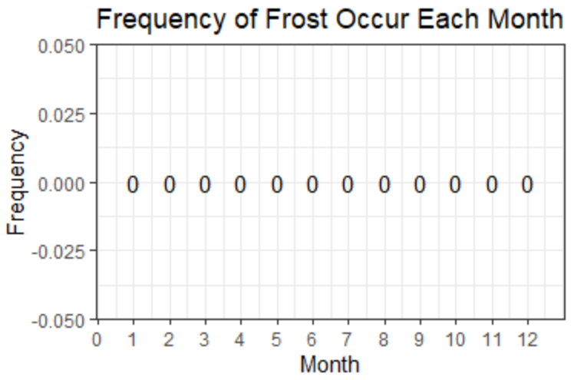
The graph above shows the frequency of frost occur for each month. What is frost? According to (Knowledge, 2016), frost happens when temperature drop lower than dewpoint and the temperature lower or equal to 0 degree which is freezing point. Frost can cause a definite flight safety hazard as it disrupts the flow of air over the wing and decrease the production of life drastically. Luckily, there is no frost occur over the year, else the airport is required to delay the flight.
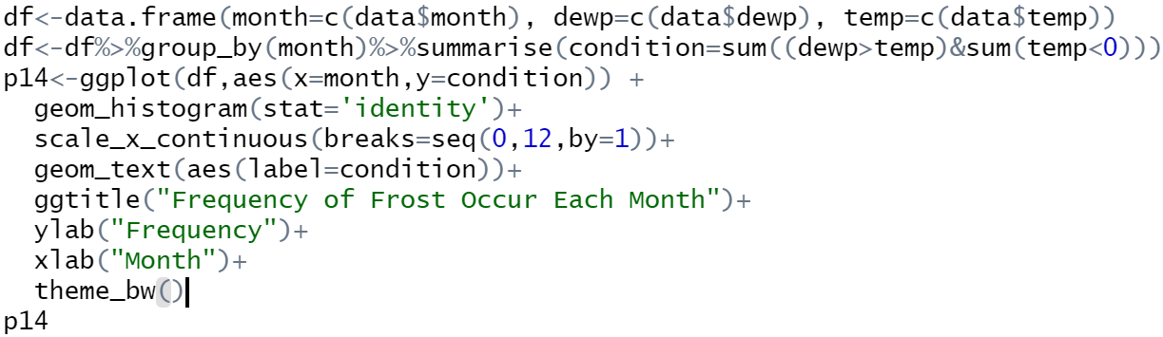
I started off by creating a data frame to store the data needed which are month, dewpoint and temperature. Then, I group the data according to month. Next, I summarized the data into a single row by taking the total frequency of dewpoint greater than temperature and temperature lower than 0 degree for each month. I use the value of month as x-axis for the graph. I use histogram to present the data. The label value of the y-axis is set. I use geom_text to create label for frequency for each bar. The title of y-axis and x-axis title of graph is changed. I then set the background theme of the graph.

Analysis 15: Mean Humidity of Each Month
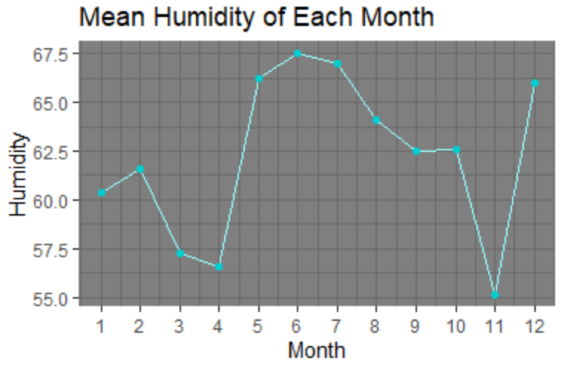
The graph shows the mean humidity of each month. Clouds is made out of water and ice. When humidity is low, less clouds will form as there is no water to be used to make clouds. However, when the humidity increase, there will be more water in the air which allows more clouds to be produced. As the humidity increase, more clouds form (Drew, Misha, Jenna M, 2010). This may affect the vision of the pilots during a flight. Therefore, a warning should be made to warn the pilots to be more caution during the flight.
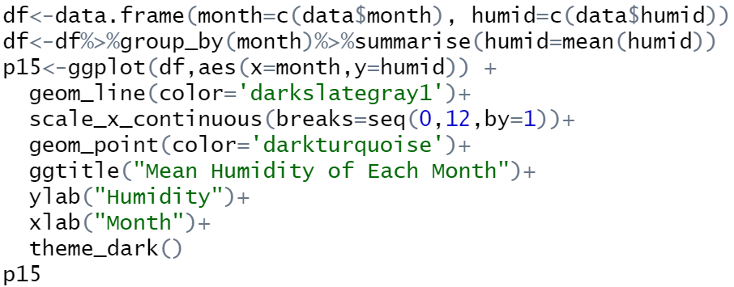

I started off by creating a data frame to store the data needed which are month and humidity. Then, I group the data according to month. Next, I summarized the data into a single row by taking the mean humidity of each month. I use the value of month as x-axis and humidity as y-axis for the graph. I use line and point in visualizing the data. The line and point takes the color of darkslategray1 and darkturquoise respectively. The title of y-axis,x-axis, and title of graph is changed. I then set the background theme of the graph.

Analysis 16: Max Temperature of Each Month
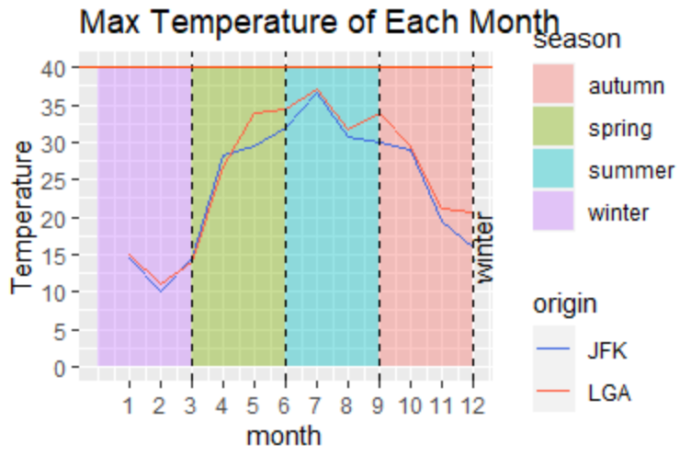
The graph above shows the max temperature of each month. In the summer, the max temperature is highest while in the winter the max temperature is the lowest. The red horizontal line indicates the temperature (40 degree) where it can be impossible for aircraft to takeoff depending on the aircraft type (HOPE, 2017). In this particular situation, airport need to prepare for flight disruptions and delay or even cancel the flight.
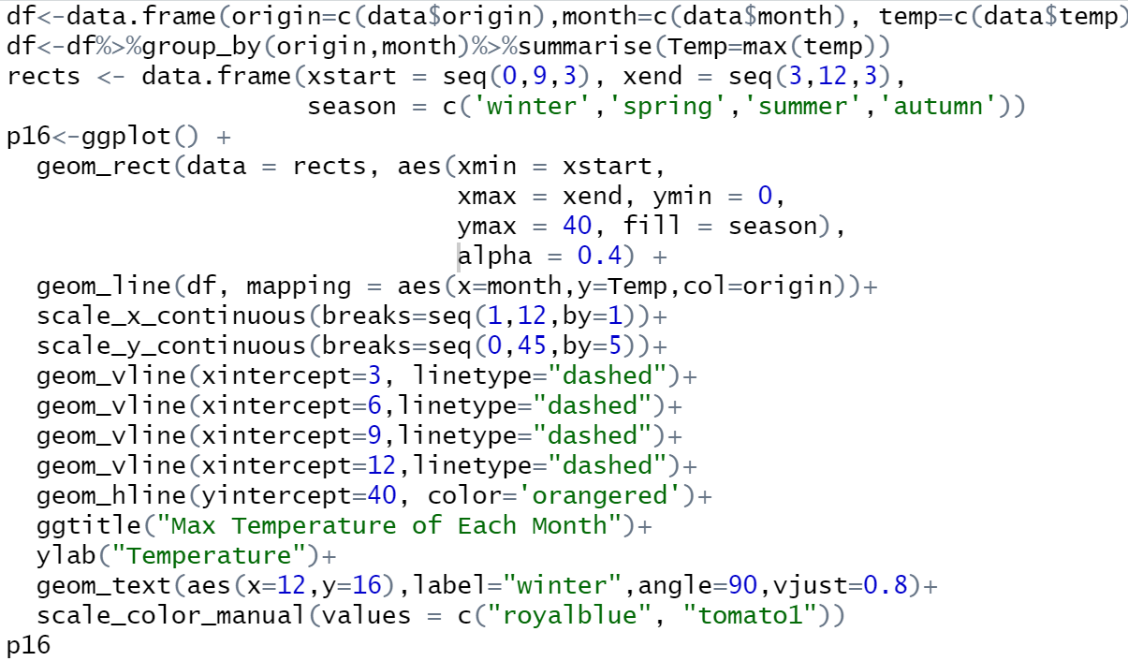
I started off by creating a data frame to store the data needed which are origin, month and temperature. Then, I group the data according to origin and month. Next, I summarized the data into a single row by taking the mean temperature for each month. I then created a data frame call rects which store the xstart, xend, and season column. I then start to plot the graph. I first use geom_rect to create rectangles. The xmin specifies where the rectangle start from the x-axis, xmax specifies where the rectangle ends at the x-axis. They ymin specifies the start point of the rectangle from the y-axis, and the yend specifies the end point of the rectangle from y-axis. The fill specifies the rectangle based on the season using different color of background. Alpha represent the opacity of the plot. I created the a line on the graph using geom_line which takes data from data frame “df”. I set the month to the x-axis, meanTemp to y-axis, and origin to col which draw 2 different color of lines represent 2 different origin. Then, I set the label value along the x and y axis which x axis start from 1 to 12 which the value increment by 1, I did the same to the label of y-axis. I plotted a vertical line on the x-intercept of 3, 6, 9, and 12 with the dashed line. I set the title using ggtitle and I write a text on the graph where the position is on the value of 12 for x-axis and 16 for y-axis, the name of the label is set to “winter” the word is position on the angle of 90 degree. I change the color of the lines to royalblue and tomato1.

Extra Feature 1
The background of the graph is one of the extra features in which I set seasons based on the background of the graph. This can actually provide a better vision on the data distribution which we can know based on seasons how the line changes. For example, we can know that in the season of summer, the mean temperature should be highest.
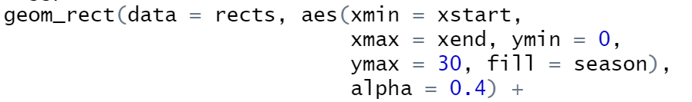
First, I declare a data frame to store some data. Then, I used geom_rect to plot rectangle which takes the value from the previous data frame I declared: rects. The xmin represent the starting position of the rectangle in x-axis. The xmax represent the ending position of rectangle in x-axis. The ymin represent the starting position of y-axis. The ymax represent the ending position of y-axis. The fill is used to put color to the rectangle based on the seasons. The alpha is the opacity of the rectangle.

Extra Feature 2
The red line is also one of the extra features that I have implemented. The red line represent the minimum visibility to takeoff. The red line can give a better vision to the viewer on the minimum visibility that is allowed to takeoff. Viewer can know how many months have visibility that is below the takeoff point.
This is how I implemented the code for the red line. I use geom_hline which creates a horizontal line on the graph. Then, I positioned the red line on the y-intercept of 201m and the color I set to orangered.

Conclusion
In conclusion, I have learnt to visualize data in graph form, data manipulation by converting the unit of the column, data exploration to understand what is in the dataset and the characteristics of the data. Besides, I have also required a lot of knowledge regarding weather and aircraft. Analysis of data is important to figure out how variables affect each other. Furthermore, analysis can also help in making decision and finding the pattern of the data. This is crucial as it can helps in predicting the possibilities of an event based on previous record.

References
DiBonaventuro, F., 2017. PhysLink.com. [Online]
Available at: https://www.physlink.com/education/askexperts/ae652.cfm
[Accessed 31 10 2020].
Drew, Misha, Jenna M, 2010. Windows To The Universe. [Online]
Available at: https://www.windows2universe.org/kids_space/humidity.html#:~:text=Humidity%20is%20important%20for%20clouds,more%20clouds%20we%20can%20have.
[Accessed 30 10 2020].
HOPE, A., 2017. Conde Nast Traveler. [Online]
Available at: https://www.cntraveler.com/stories/2016-06-20/its-so-hot-some-planes-cant-fly-heres-why
[Accessed 27 10 2020].
Jfkrotaryclub, 2017. jfkrotaryclub. [Online]
Available at: https://www.jfkrotaryclub.org/jfkrun/runways/#:~:text=a%2Dmile%20visibility.-,Takeoffs%20can%20be%20made%20with%20visibility%20of%20one%2Deighth%20of,commercial%20runways%20in%20North%20America.
[Accessed 30 10 2020].
Knowledge, P. H. o. A., 2016. Pilots Handbook of Aeronautical Knowledge. Pilots Handbook of Aeronautical Knowledge.indb, 2(Weather Theory), p. 26.
Schrader, R., 2019. Skyscanner. [Online]
Available at: https://www.skyscanner.com/tips-and-inspiration/what-windspeed-delays-flights#:~:text=With%20this%20in%20mind%2C%20horizontal,of%20take%2Doff%20and%20landing.
[Accessed 28 10 2020].

